IHC Norway Survey

Chris Rose, Folkehelseinstituttet (2020-02-17)

This report was generated on Mon Feb 17 10:49:57 2020 using revision b4ef596.

## Overview

This document describes the methods and results of the survey of Norwegians’ understanding of key concepts for Informed Health Choices.

## Methods

### Norwegians’ understanding of the key concepts, attitudes, and intended behaviors

We developed four different questionnaires to cover 31 of the key concepts. Questions on four concepts of particular interest (“Old is better!”, “Associated with!”, “A study shows!”, and “Dissimilar comparison groups”) were included in all questionnaires. The first questionnaire included translations into Norwegian Bokmål of the same questions used in our previous randomized controlled trials in Uganda, facilitating comparison of Norwegians and Ugandans (see below). We used survey responses to estimate the percentage of the adult Norwegian population that understands each concept, and that agrees with each of seven statements about attitudes and intended behaviors. We classified a participant as understanding a concept if they correctly answered all questions on the concept.

To address the likely problem of non-random non-response, we used iterative post-stratification to match marginal distributions of sex, educational attainment level, and statistical region of residence of the sample to the Norwegian population, as described below. We did not collect data on participant age and could not use it for post-stratification as planned.

We obtained Eurostat data on the marginal distributions of sex and statistical region of residence for all Norwegians, and educational attainment level for Norwegians aged 15 to 64 years (data sets TPS00002, TGS00096, and edat_lfse_03). Participants reported their “fylke” (county) of residence. We mapped these to the corresponding Nomenclature of Territorial Units for Statistics (NUTS 2) regions of Norway reported by Eurostat. Participants reported the highest level of education they attained using Norwegian terminology (e.g., “Grunnskolen”, “Videregående”). We mapped these to the corresponding International Standard Classification of Education 2011 categories reported by Eurostat (levels 0–2, 3–4, and 5–8). We then used multiple imputation using chained equations to account for missing values of the post-stratification variables. We performed imputation using: the post-stratification variables (sex, region of residence, and educational attainment); demographic variables that code for whether participants had training in research or medicine, or if they had been a research participant; and the dependent variable (whether they understood a particular concept). We iteratively post-stratified each imputed data set and estimated the percentage of the Norwegian population that understands each key concept, and that agrees with each of statements about attitudes and intended behaviors. We used the R packages mice, mitools, survey, and tidyverse.

We present summaries of the sample (numbers, sample sizes, and percentages) and post-stratified population estimates for the 31 key concepts, and seven attitudes and intended behaviors. We quantified uncertainty on our estimates using 95% confidence intervals, and protected the family-wise coverage probability of the confidence intervals for the four key concepts included in all questionnaires via Bonferroni-correction.

### Comparisons to Ugandans

We used data from the first questionnaire and our previous randomized controlled trials in Uganda to compare mean test scores, and probabilities of achieving passing and mastery scores, between Norwegian adults and Ugandan parents (controls who did not listen to a podcast intervention, and took the test at the time of the original trial), teachers (controls who took the test one year after the original trial), and children (assigned either to a podcast intervention or a control group, and who took the test one year after the original trial). We defined passing as answering at least 13 of 24 questions correctly (at least 11 of 18 for Ugandan parents), and mastery as answering at least 20 of 24 questions correctly (at least 15 of 18 for Ugandan parents), as in the original trials.

We estimated mean scores and odds ratios using generalized linear mixed-effects models (GLMMs; normal errors and identity link for mean scores, binomial errors and logit link for passing and mastery) using the lme4 R package. In the trials, school was the randomized unit for children and teachers, while parents were individually randomized. We modelled this clustering structure using random effects (a random intercept for each randomized unit). We did not adjust for other covariates. No data were missing and we did not apply post-stratification weights for Norwegians.

For mean scores, we present a table of estimates of population means and differences in means relative to the Ugandan children, and a forest plot of the mean scores. For passing and mastery, we present tables of estimates of odds ratios comparing each group to Ugandan children, probabilities (“risks”, calculated from the estimated coefficients of the GLMMs), and differences in probabilities (“risk differences”) relative to the Ugandan children. Odds ratios less than unity and differences less than zero favor the children. We quantify uncertainty on estimates using 95% confidence intervals and *P* values.

### Exploratory analyses

#### Key concepts

We performed exploratory analyses to investigate how Norwegians’ understanding of each key concept is associated with the demographic covariates sex, research training, research participation, education, and medical education. We used generalized linear models (quasibinomial errors, logit link) to model understanding of each concept in terms of the covariates, which were modelled as categorical variables. Multiple imputation and post-stratification were used as in the main analysis.

#### Attitudes and intended behaviors

We also performed exploratory analyses to investigate how Norwegians’ attitudes and intended behaviors are associated with the demographic covariates sex, research training, research participation, education, and medical education. Analyses were performed in the same way as for the exploratory analyses for the key concepts.

#### Mean score, passing, and mastery

We used data from the first questionnaire to perform exploratory analyses to investigate how Norwegians’ mean scores and achievement of passing and mastery scores are associated with the demographic covariates sex, research training, research participation, education, and medical education. We used generalized linear models (normal errors and identity link for mean score; quasibinomial errors and logit link for passing and mastery) to model the outcomes in terms of the covariates, which were modelled as categorical variables. Multiple imputation and post-stratification were used as in the main analysis. We performed imputation using: the post-stratification variables (sex, region of residence, and educational attainment); demographic variables that code for whether participants had training in research or medicine, and if they had been a research participant; and mean score (which is directly related to the outcomes passing and mastery).

## Results

### Participant characteristics

The following table shows participant characteristics across the four questionnaires. For each level of each stratification variable, Fisher’s exact test is used to assess the strength evidence against the null hypothesis of equal proportions across the four questionnaires (**NOTE:** this column is for information only and may be dropped from the final table). Of the 771 respondents, 21 (2.7%) did not provide data on at least of one the covariates sex, research training, research participation, education, medical education, and county of residence.

|  |  |  |  |  |  |  |  |
| --- | --- | --- | --- | --- | --- | --- | --- |
|  |  | Quiz 1 | Quiz 2 | Quiz 3 | Quiz 4 | P-value | Overall |
| All |  | 210 (27.2%) | 211 (27.4%) | 172 (22.3%) | 178 (23.1%) | 1 | 771 (100.0%) |
| Sex | Female | 103 (13.4%) | 102 (13.2%) | 102 (13.2%) | 94 (12.2%) | 0.63355 | 401 (52.0%) |
|  | Male | 107 (13.9%) | 109 (14.1%) | 70 (9.1%) | 83 (10.8%) | 0.56449 | 369 (47.9%) |
|  | Missing | 0 (0.0%) | 0 (0.0%) | 0 (0.0%) | 1 (0.1%) | 0.45466 | 1 (0.1%) |
| Education | Primary | 12 (1.6%) | 16 (2.1%) | 5 (0.6%) | 10 (1.3%) | 0.30396 | 43 (5.6%) |
|  | Secondary | 53 (6.9%) | 53 (6.9%) | 42 (5.4%) | 49 (6.4%) | 0.95886 | 197 (25.6%) |
|  | Tertiary (1-2 years) | 23 (3.0%) | 30 (3.9%) | 21 (2.7%) | 33 (4.3%) | 0.29255 | 107 (13.9%) |
|  | Tertiary (3-5 years) | 71 (9.2%) | 69 (8.9%) | 58 (7.5%) | 51 (6.6%) | 0.86021 | 249 (32.3%) |
|  | Masters degree | 39 (5.1%) | 36 (4.7%) | 41 (5.3%) | 30 (3.9%) | 0.49704 | 146 (18.9%) |
|  | PhD | 10 (1.3%) | 5 (0.6%) | 5 (0.6%) | 3 (0.4%) | 0.38534 | 23 (3.0%) |
|  | Missing | 2 (0.3%) | 2 (0.3%) | 0 (0.0%) | 2 (0.3%) | 0.67033 | 6 (0.8%) |
| Research training | No | 126 (16.3%) | 145 (18.8%) | 105 (13.6%) | 126 (16.3%) | 0.66839 | 502 (65.1%) |
|  | Yes | 84 (10.9%) | 66 (8.6%) | 65 (8.4%) | 52 (6.7%) | 0.35023 | 267 (34.6%) |
|  | Missing | 0 (0.0%) | 0 (0.0%) | 2 (0.3%) | 0 (0.0%) | 0.050443 | 2 (0.3%) |
| Research participant | No | 146 (18.9%) | 157 (20.4%) | 121 (15.7%) | 126 (16.3%) | 0.97134 | 550 (71.3%) |
|  | Yes | 63 (8.2%) | 52 (6.7%) | 50 (6.5%) | 51 (6.6%) | 0.80132 | 216 (28.0%) |
|  | Missing | 1 (0.1%) | 2 (0.3%) | 1 (0.1%) | 1 (0.1%) | 1 | 5 (0.6%) |
| Medical education | No | 175 (22.7%) | 168 (21.8%) | 133 (17.3%) | 147 (19.1%) | 0.96116 | 623 (80.8%) |
|  | Yes | 35 (4.5%) | 43 (5.6%) | 37 (4.8%) | 28 (3.6%) | 0.57834 | 143 (18.5%) |
|  | Missing | 0 (0.0%) | 0 (0.0%) | 2 (0.3%) | 3 (0.4%) | 0.061528 | 5 (0.6%) |
| County | Akershus | 27 (3.5%) | 28 (3.6%) | 16 (2.1%) | 21 (2.7%) | 0.72691 | 92 (11.9%) |
|  | Aust-Agder | 4 (0.5%) | 2 (0.3%) | 2 (0.3%) | 2 (0.3%) | 0.87829 | 10 (1.3%) |
|  | Buskerud | 7 (0.9%) | 7 (0.9%) | 14 (1.8%) | 8 (1.0%) | 0.162 | 36 (4.7%) |
|  | Finnmark | 5 (0.6%) | 2 (0.3%) | 3 (0.4%) | 1 (0.1%) | 0.48594 | 11 (1.4%) |
|  | Hedmark | 2 (0.3%) | 3 (0.4%) | 4 (0.5%) | 3 (0.4%) | 0.76607 | 12 (1.6%) |
|  | Hordaland | 16 (2.1%) | 29 (3.8%) | 9 (1.2%) | 20 (2.6%) | 0.048787 | 74 (9.6%) |
|  | Møre og Romsdal | 8 (1.0%) | 3 (0.4%) | 6 (0.8%) | 9 (1.2%) | 0.24526 | 26 (3.4%) |
|  | Nordland | 9 (1.2%) | 9 (1.2%) | 5 (0.6%) | 6 (0.8%) | 0.89401 | 29 (3.8%) |
|  | Oppland | 3 (0.4%) | 9 (1.2%) | 5 (0.6%) | 5 (0.6%) | 0.40473 | 22 (2.9%) |
|  | Oslo | 38 (4.9%) | 29 (3.8%) | 38 (4.9%) | 26 (3.4%) | 0.27531 | 131 (17.0%) |
|  | Østfold | 11 (1.4%) | 9 (1.2%) | 14 (1.8%) | 7 (0.9%) | 0.37221 | 41 (5.3%) |
|  | Rogaland | 25 (3.2%) | 35 (4.5%) | 18 (2.3%) | 20 (2.6%) | 0.40053 | 98 (12.7%) |
|  | Sogn og Fjordane | 3 (0.4%) | 2 (0.3%) | 4 (0.5%) | 1 (0.1%) | 0.53125 | 10 (1.3%) |
|  | Telemark | 7 (0.9%) | 5 (0.6%) | 4 (0.5%) | 9 (1.2%) | 0.47175 | 25 (3.2%) |
|  | Troms | 6 (0.8%) | 8 (1.0%) | 3 (0.4%) | 7 (0.9%) | 0.64403 | 24 (3.1%) |
|  | Trøndelag | 19 (2.5%) | 14 (1.8%) | 13 (1.7%) | 15 (1.9%) | 0.84835 | 61 (7.9%) |
|  | Vest-Agder | 6 (0.8%) | 10 (1.3%) | 6 (0.8%) | 11 (1.4%) | 0.4576 | 33 (4.3%) |
|  | Vestfold | 12 (1.6%) | 6 (0.8%) | 7 (0.9%) | 6 (0.8%) | 0.53705 | 31 (4.0%) |
|  | Missing | 2 (0.3%) | 1 (0.1%) | 1 (0.1%) | 1 (0.1%) | 1 | 5 (0.6%) |

### Norwegians’ understanding of the key concepts, attitudes, and intended behaviors

#### Key concepts

We designed the survey to provide estimates of Norwegians’ understanding of the key concepts with confidence intervals no wider than ±5% (for the four concepts common to all questionnaires) and ±8% (for the other concepts, and the attitudes and intended behaviors). This was achieved on average, but not for every concept. The mean width of the confidence intervals for the four concepts common to all questionnaires was ±4.58% (range ±3.61% to ±5.91%). The mean width of the other confidence intervals was ±7.92% (range ±3.37% to ±11.9%; 15 of the 30 concepts had confidence intervals wider than ±8%).

The following table shows estimates of the percentage of the Norwergian population that understands each of the key concepts.

|  |  |  |  |
| --- | --- | --- | --- |
|  | Sample |  | Post-stratified Estimate (95% CI) |
| Increasing the amount of a treatment does not necessarily increase its benefits and may cause harm | 191 / 211 | (91%) | 92% (88% to 96%) |
| The people being compared should be cared for similarly apart from the treatments being studied | 186 / 211 | (88%) | 87% (81% to 93%) |
| Competing interests may result in misleading claims | 176 / 210 | (84%) | 84% (77% to 91%) |
| Weigh the benefits and savings against the harms and costs of acting or not | 179 / 210 | (85%) | 83% (77% to 90%) |
| Personal experiences or anecdotes alone are an unreliable basis for most claims | 182 / 210 | (87%) | 82% (74% to 90%) |
| If possible, people should not know which of the treatments being compared they are receiving | 178 / 210 | (85%) | 78% (69% to 86%) |
| Attention should focus on all important effects of treatments, and not surrogate outcomes | 141 / 178 | (79%) | 76% (67% to 85%) |
| Small studies may be misleading | 176 / 210 | (84%) | 74% (66% to 83%) |
| Treatments that are new or technologically impressive may not be better than available alternatives | 156 / 210 | (74%) | 70% (62% to 79%) |
| Opinions alone are not a reliable basis for claims | 159 / 210 | (76%) | 68% (59% to 77%) |
| Fair comparisons of treatments in animals or highly selected groups of people may not be relevant | 111 / 172 | (65%) | 67% (57% to 77%) |
| It is important to assess outcomes in all (or nearly all) the people in a study | 139 / 211 | (66%) | 64% (56% to 72%) |
| The treatments compared should be similar to those of interest | 107 / 172 | (62%) | 56% (44% to 68%) |
| Identifying effects of treatments depends on making comparisons | 143 / 210 | (68%) | 56% (47% to 65%) |
| An outcome may be associated with a treatment but not caused by it‡ | 490 / 771 | (64%) | 56% (50% to 61%) |
| Reviews of studies comparing treatments should use systematic methods | 120 / 211 | (57%) | 51% (42% to 59%) |
| Outcomes should be assessed in the same way in all the groups being compared | 116 / 211 | (55%) | 50% (42% to 58%) |
| Earlier detection of ‘disease’ is not necessarily better | 75 / 178 | (42%) | 39% (30% to 48%) |
| Relative effects of treatments alone can be misleading | 52 / 178 | (29%) | 34% (25% to 43%) |
| Deeming results to be “statistically significant” or “nonsignificant” can be misleading | 49 / 178 | (28%) | 33% (24% to 42%) |
| Average differences between treatments can be misleading | 50 / 178 | (28%) | 30% (20% to 39%) |
| Large, dramatic effects are rare | 63 / 211 | (30%) | 28% (20% to 36%) |
| Consider how certain you can be about each advantage and disadvantage | 49 / 172 | (28%) | 22% (13% to 31%) |
| Widely used treatments or those that have been used for decades are not necessarily beneficial or safe‡ | 164 / 771 | (21%) | 20% (15% to 25%) |
| The use of p-values may be misleading; confidence intervals are more informative | 33 / 178 | (19%) | 18% (10% to 25%) |
| Beliefs alone about how treatments work are not reliable predictors of the presence or size of effects | 39 / 211 | (18%) | 17% (12% to 23%) |
| Comparison groups should be as similar as possible‡ | 149 / 771 | (19%) | 15% (12% to 19%) |
| The results of one study considered in isolation can be misleading‡ | 90 / 771 | (12%) | 12% (8% to 16%) |
| People’s outcomes should be counted in the group to which they were allocated | 14 / 178 | (7.9%) | 10% (3.4% to 17%) |
| Results for a selected group of people within a study can be misleading | 17 / 178 | (9.6%) | 6.5% (3.1% to 9.8%) |
| ‡ Confidence intervals have been Bonferroni-corrected. |  |  |  |

The above results are presented graphically in the figure below:

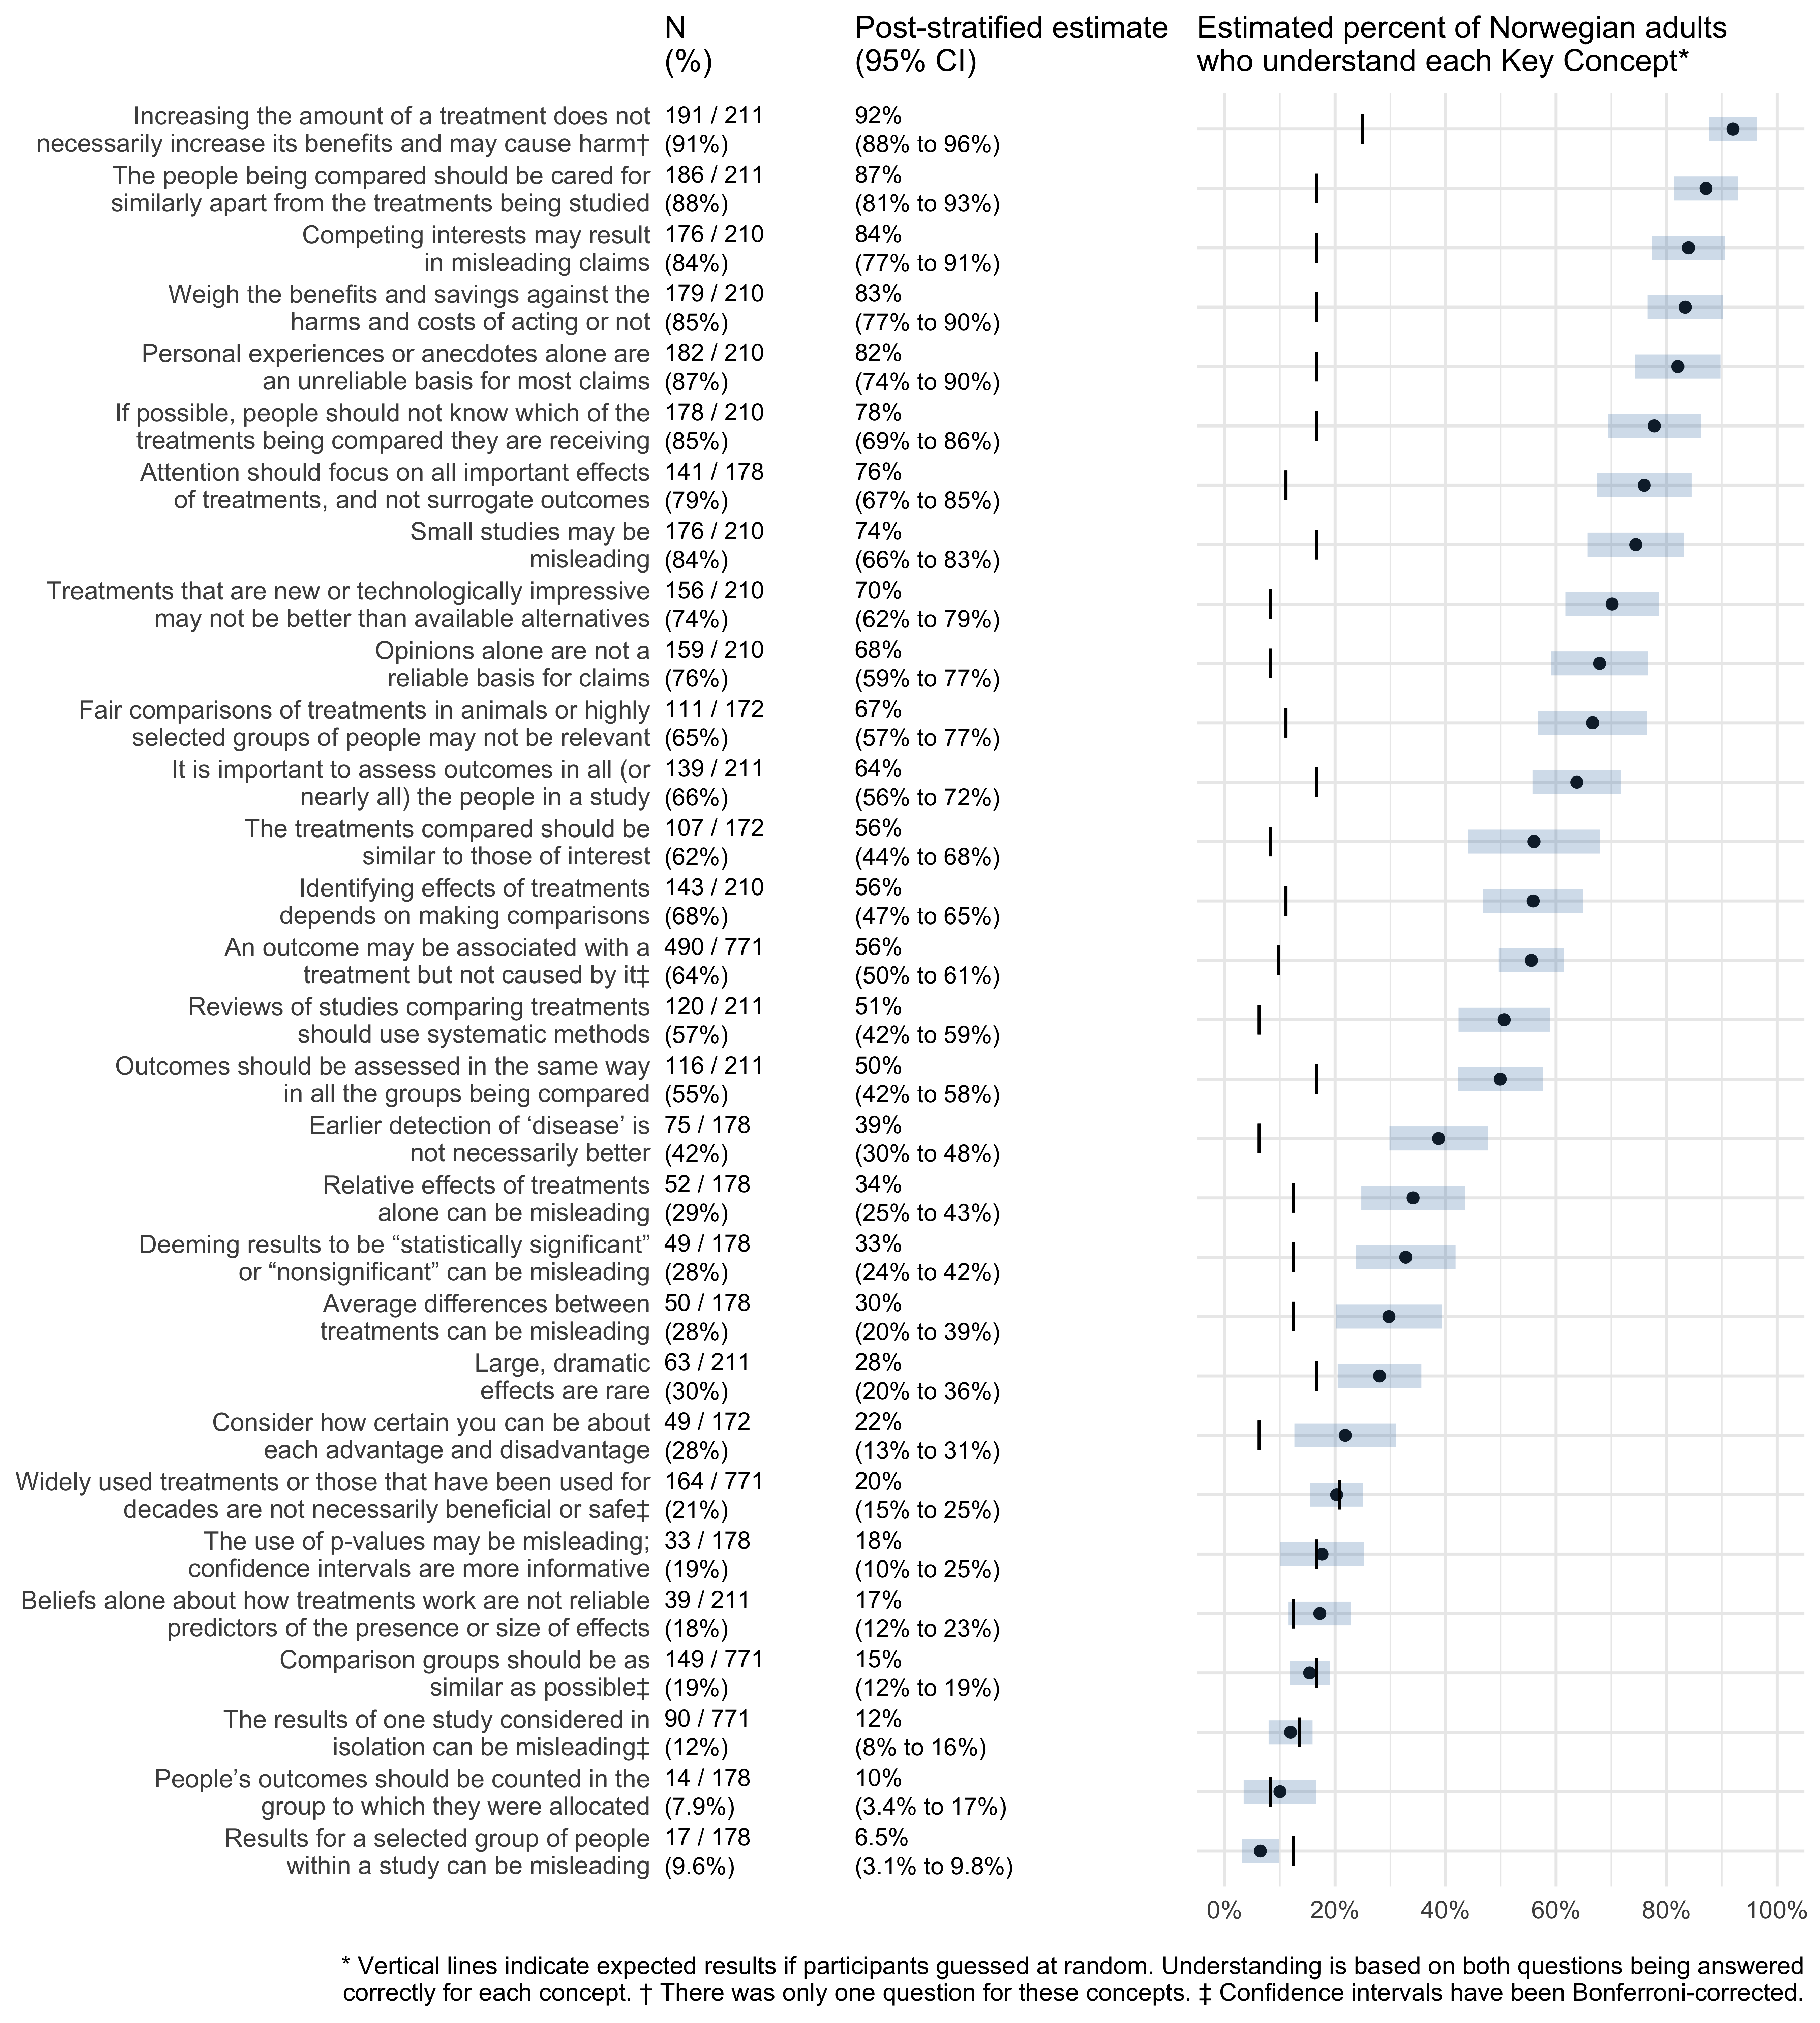

#### Attitudes and intended behaviors

The following table shows estimates for attitudes and intended behaviors.

|  |  |  |  |
| --- | --- | --- | --- |
|  | Sample |  | Post-stratified Estimate (95% CI) |
| Willing to challenge claims? | 140 / 172 | (81%) | 75% (66% to 85%) |
| Likely to research the basis of claims? | 130 / 172 | (76%) | 70% (59% to 81%) |
| Willing to take part in research? | 541 / 771 | (70%) | 67% (63% to 72%) |
| Easy to assess the relevance of study results? | 35 / 172 | (20%) | 21% (9.1% to 33%) |
| Easy to assess if claims are based on research that compares treatments? | 42 / 172 | (24%) | 18% (12% to 25%) |
| Easy to find research based on studies that compare treatments? | 36 / 172 | (21%) | 18% (8.7% to 28%) |
| Easy to assess the credibility of results of studies that compare treatments? | 32 / 172 | (19%) | 16% (5.7% to 26%) |

The above results are presented graphically in the figure below.

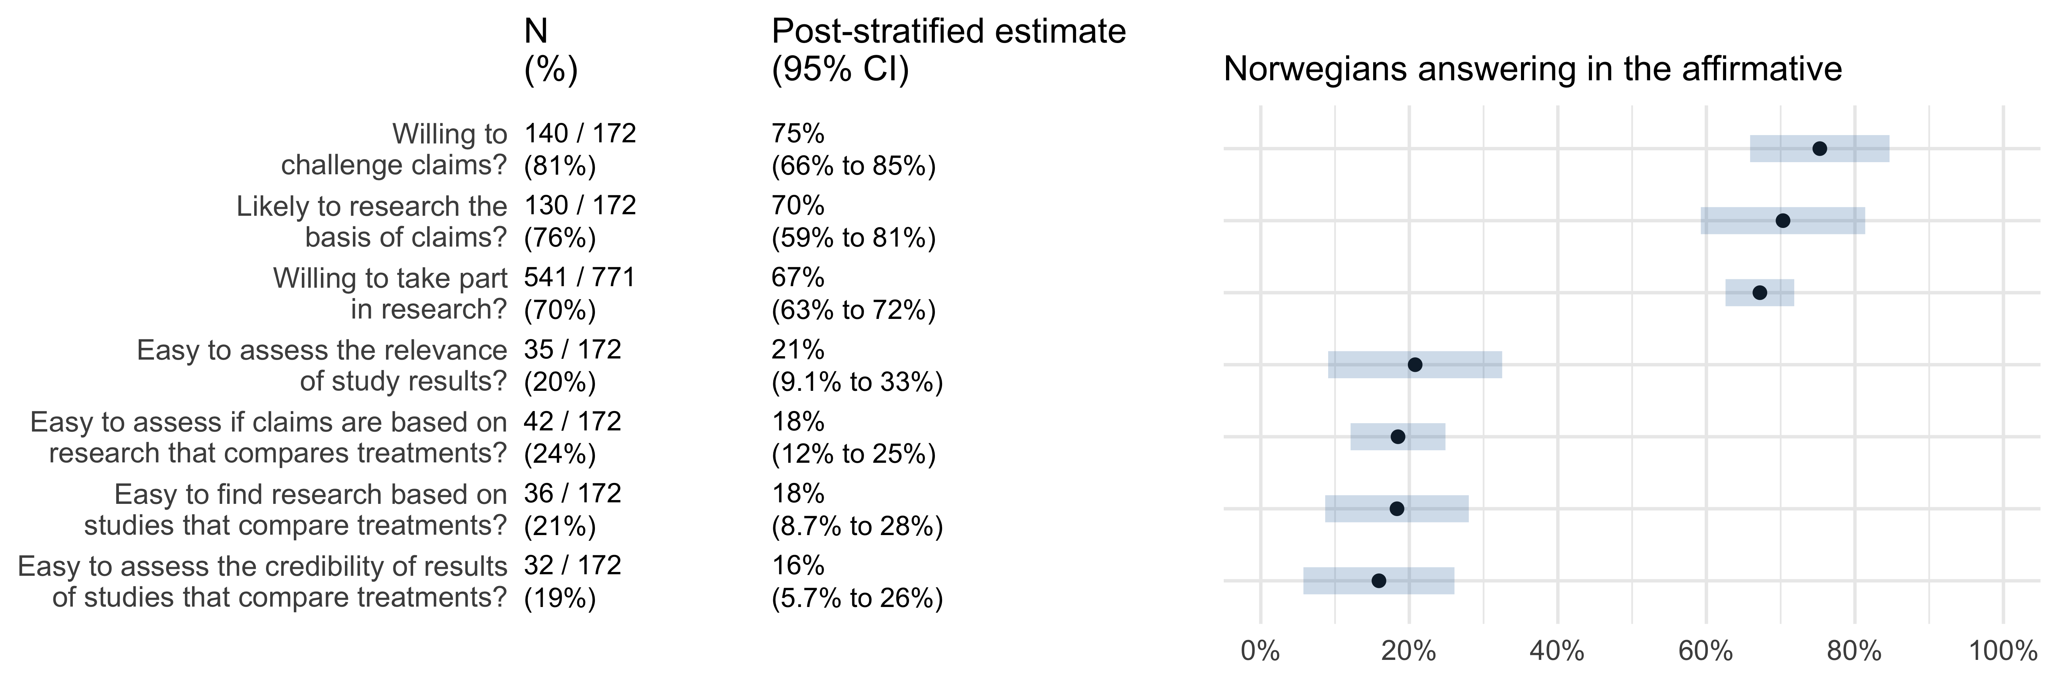

### Comparisons to Ugandans

#### Mean score

The following table compares mean test scores of Norwegians and Ugandans parents.

|  |  |  |  |  |
| --- | --- | --- | --- | --- |
|  | n | Mean score (95% CI) | Difference (95% CI) | P-value |
| Ugandan Children (Intervention) | 3943 | 69% (67% to 71%) | 0 |  |
| Ugandan Parents (Control) | 256 | 53% (48% to 57%) | -16% (-19% to -13%) | <0.0001 |
| Ugandan Teachers (Control) | 59 | 68% (61% to 75%) | -0.59% (-5.6% to 4.4%) | 0.82 |
| Ugandan Teachers (Podcast) | 78 | 86% (81% to 92%) | 17% (14% to 21%) | <0.0001 |
| Norwegian Adults | 210 | 86% (81% to 91%) | 17% (14% to 20%) | <0.0001 |

The above results are presented graphically in the figure below.

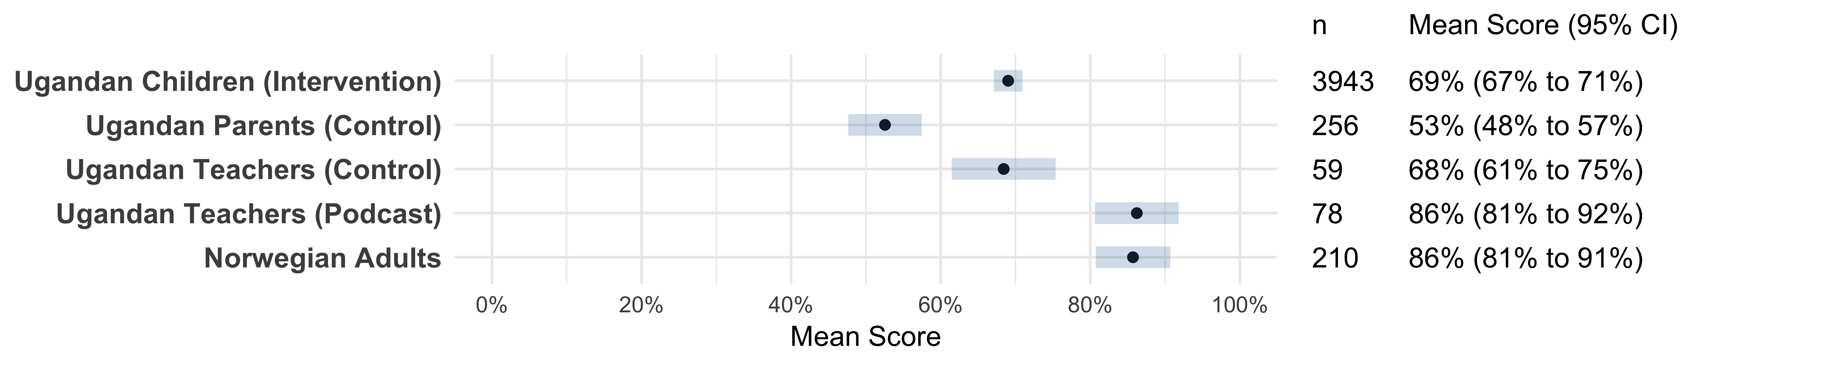

#### Passing

|  |  |  |  |  |  |  |
| --- | --- | --- | --- | --- | --- | --- |
|  | Sample |  | Probability (95% CI) | Difference (95% CI) | Odds ratio (95% CI) | P value |
| Ugandan Children (Intervention) | 3160 / 3943 | (80.1%) | 84% (81% to 88%) | 0 | 1 |  |
| Ugandan Parents (Control) | 101 / 256 | (39.5%) | 37% (28% to 47%) | -47% (-56% to -37%) | 0.11 (0.073 to 0.17) | <0.0001 |
| Ugandan Teachers (Control) | 50 / 59 | (84.7%) | 88% (76% to 94%) | 3.4% (-8.5% to 9.9%) | 1.3 (0.58 to 3) | 0.4984 |
| Ugandan Teachers (Podcast) | 77 / 78 | (98.7%) | 99% (94% to 100%) | 15% (9.7% to 15%) | 21 (3 to 150) | 0.0023 |
| Norwegian Adults | 209 / 210 | (99.5%) | 100% (98% to 100%) | 15% (13% to 16%) | 54 (7.5 to 400) | <0.0001 |

The above results are presented graphically in the figure below.

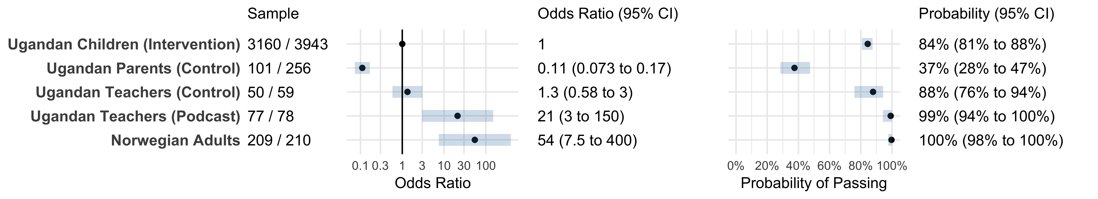

#### Mastery

|  |  |  |  |  |  |  |
| --- | --- | --- | --- | --- | --- | --- |
|  | Sample |  | Probability (95% CI) | Difference (95% CI) | Odds ratio (95% CI) | P value |
| Ugandan Children (Intervention) | 1138 / 3943 | (28.9%) | 27% (22% to 32%) | 0 | 1 |  |
| Ugandan Parents (Control) | 27 / 256 | (10.5%) | 8.1% (5.1% to 13%) | -18% (-22% to -14%) | 0.24 (0.15 to 0.4) | <0.0001 |
| Ugandan Teachers (Control) | 13 / 59 | (22.0%) | 19% (9.8% to 33%) | -8% (-17% to 5.9%) | 0.63 (0.3 to 1.3) | 0.23 |
| Ugandan Teachers (Podcast) | 53 / 78 | (67.9%) | 70% (59% to 80%) | 44% (32% to 53%) | 6.6 (3.9 to 11) | <0.0001 |
| Norwegian Adults | 133 / 210 | (63.3%) | 66% (56% to 74%) | 39% (29% to 48%) | 5.3 (3.5 to 7.9) | <0.0001 |

The above results are presented graphically in the figure below.

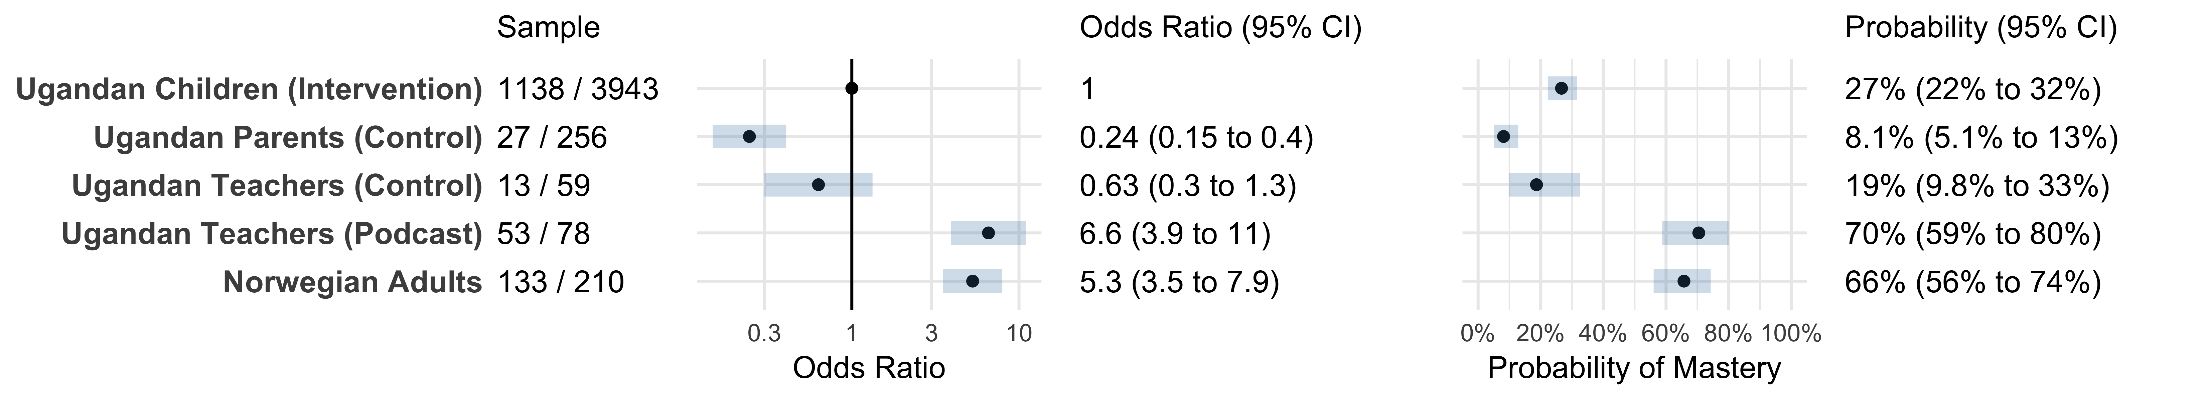

### Exploratory analyses

#### Key concepts

The following table presents the results of the analysis performed to explore associations between demographic covariates and Norwegians’ understanding of the key concepts. Results are presented as odds ratios. Odds ratios greater than unity indicate that a covariate is associated with better understanding.

Note that some odds ratios are clearly misestimated for some concepts. For example, the intercept term for the concept “Results for a selected group of people within a study can be misleading” (i.e., a “reference” individual’s odds for understanding the concept) is estimated to be 2.3e-09 (8.2e-10 to 6.2e-09). Formal testing for collinearity, singularity, outliers, and goodness of fit failed to identify these specific problems, however visual inspection of the data suggests that the problem may be explained by collinearity between the dependent variable (understanding the concept) and education (ISCED level).

|  |  |  |  |  |  |  |  |  |  |
| --- | --- | --- | --- | --- | --- | --- | --- | --- | --- |
|  | Sample |  | Intercept | Male | Research training | Research participant | ISCED Levels 3-4 | ISCED Levels 5-8 | Medical education |
| Treatments that are new or technologically impressive may not be better than available alternatives | 156 / 210 | (74%) | 1.3 (0.38 to 4.4) | 1.6 (0.66 to 3.7) | 1.4 (0.5 to 3.8) | 1.4 (0.51 to 3.8) | 1.1 (0.31 to 4) | 1.6 (0.44 to 5.7) | 1.3 (0.43 to 3.7) |
| Competing interests may result in misleading claims | 176 / 210 | (84%) | 7 (1.5 to 33) | 1 (0.39 to 2.7) | 2 (0.82 to 5) | 0.45 (0.13 to 1.6) | 0.74 (0.14 to 3.9) | 0.75 (0.15 to 3.9) | 0.95 (0.29 to 3.1) |
| Opinions alone are not a reliable basis for claims | 159 / 210 | (76%) | 1.4 (0.42 to 4.5) | 1.3 (0.53 to 3) | 2.6 (1.1 to 6.3) | 0.77 (0.26 to 2.3) | 0.84 (0.22 to 3.2) | 2 (0.5 to 8.3) | 1.2 (0.37 to 3.7) |
| Personal experiences or anecdotes alone are an unreliable basis for most claims | 182 / 210 | (87%) | 4.4 (1.1 to 17) | 0.22 (0.061 to 0.76) | 5.6 (1.2 to 26) | 0.63 (0.17 to 2.3) | 2.7 (0.62 to 12) | 4.3 (1.2 to 16) | 0.72 (0.15 to 3.3) |
| Weigh the benefits and savings against the harms and costs of acting or not | 179 / 210 | (85%) | 3.3 (0.78 to 14) | 0.95 (0.35 to 2.5) | 1.5 (0.54 to 4.3) | 1.3 (0.31 to 5.4) | 1.4 (0.33 to 6.3) | 1.4 (0.34 to 5.8) | 1.7 (0.48 to 5.8) |
| Widely used treatments or those that have been used for decades are not necessarily beneficial or safe | 164 / 771 | (21%) | 0.23 (0.11 to 0.52) | 0.99 (0.61 to 1.6) | 1.8 (1 to 3.1) | 0.95 (0.58 to 1.6) | 1 (0.45 to 2.3) | 0.98 (0.45 to 2.1) | 0.71 (0.4 to 1.3) |
| An outcome may be associated with a treatment but not caused by it | 490 / 771 | (64%) | 0.55 (0.29 to 1.1) | 1.1 (0.69 to 1.6) | 2.4 (1.5 to 4) | 1.4 (0.83 to 2.2) | 1.7 (0.83 to 3.3) | 2.5 (1.3 to 4.8) | 1.2 (0.69 to 1.9) |
| Small studies may be misleading | 176 / 210 | (84%) | 1.3 (0.38 to 4.4) | 0.61 (0.24 to 1.6) | 3.1 (1.1 to 9.1) | 0.78 (0.21 to 2.8) | 2.2 (0.61 to 7.6) | 6.6 (2 to 22) | 3.9 (0.68 to 22) |
| If possible, people should not know which of the treatments being compared they are receiving | 178 / 210 | (85%) | 1.8 (0.58 to 5.6) | 0.9 (0.32 to 2.5) | 0.67 (0.19 to 2.4) | 1.1 (0.32 to 3.8) | 1.8 (0.5 to 6.4) | 7.3 (1.9 to 28) | 0.82 (0.23 to 3) |
| The results of one study considered in isolation can be misleading | 90 / 771 | (12%) | 0.16 (0.061 to 0.41) | 0.79 (0.43 to 1.5) | 1.2 (0.7 to 2.2) | 1.3 (0.61 to 2.6) | 1 (0.39 to 2.6) | 0.85 (0.35 to 2.1) | 0.48 (0.22 to 1) |
| Identifying effects of treatments depends on making comparisons | 143 / 210 | (68%) | 0.73 (0.23 to 2.3) | 0.74 (0.32 to 1.7) | 5.4 (1.9 to 15) | 1.7 (0.54 to 5.2) | 0.8 (0.24 to 2.6) | 3.2 (1 to 10) | 0.58 (0.18 to 1.9) |
| Comparison groups should be as similar as possible | 149 / 771 | (19%) | 0.045 (0.0094 to 0.21) | 1.2 (0.72 to 1.9) | 1.8 (1.1 to 2.9) | 1.1 (0.68 to 1.8) | 3.7 (0.85 to 16) | 4.1 (1 to 17) | 0.95 (0.56 to 1.6) |
| Increasing the amount of a treatment does not necessarily increase its benefits and may cause harm | 191 / 211 | (91%) | 11 (1.2 to 110) | 1.6 (0.47 to 5.5) | 1.1 (0.36 to 3.1) | 2.3 (0.68 to 7.5) | 1.1 (0.11 to 11) | 0.45 (0.065 to 3.2) | 0.9 (0.27 to 3) |
| Beliefs alone about how treatments work are not reliable predictors of the presence or size of effects | 39 / 211 | (18%) | 0.043 (0.0065 to 0.28) | 1.7 (0.64 to 4.3) | 1.5 (0.57 to 3.7) | 1.7 (0.65 to 4.2) | 4.4 (0.52 to 38) | 2.9 (0.4 to 22) | 1.1 (0.38 to 3.4) |
| Large, dramatic effects are rare | 63 / 211 | (30%) | 0.42 (0.14 to 1.3) | 0.8 (0.36 to 1.8) | 1.3 (0.46 to 3.5) | 3 (1.3 to 6.9) | 0.64 (0.2 to 2.1) | 0.99 (0.3 to 3.3) | 0.47 (0.17 to 1.3) |
| The people being compared should be cared for similarly apart from the treatments being studied | 186 / 211 | (88%) | 5.9 (1.8 to 19) | 0.93 (0.32 to 2.7) | 3.2 (0.85 to 12) | 1.1 (0.43 to 2.8) | 1.5 (0.26 to 8) | 1.2 (0.23 to 6.3) | 0.31 (0.086 to 1.1) |
| Outcomes should be assessed in the same way in all the groups being compared | 116 / 211 | (55%) | 0.3 (0.1 to 0.88) | 1.6 (0.77 to 3.2) | 2.4 (0.97 to 6.2) | 1.3 (0.61 to 2.8) | 2.9 (0.9 to 9.7) | 3 (0.98 to 9) | 0.58 (0.24 to 1.4) |
| It is important to assess outcomes in all (or nearly all) the people in a study | 139 / 211 | (66%) | 1.6 (0.54 to 4.8) | 0.76 (0.34 to 1.7) | 0.77 (0.33 to 1.8) | 0.98 (0.44 to 2.2) | 1.4 (0.44 to 4.8) | 1.5 (0.48 to 4.9) | 0.93 (0.34 to 2.5) |
| Reviews of studies comparing treatments should use systematic methods | 120 / 211 | (57%) | 0.53 (0.18 to 1.6) | 1.7 (0.84 to 3.6) | 1.2 (0.53 to 2.6) | 1.8 (0.82 to 3.8) | 1.1 (0.36 to 3.5) | 2 (0.69 to 6.1) | 0.64 (0.27 to 1.5) |
| Fair comparisons of treatments in animals or highly selected groups of people may not be relevant | 111 / 172 | (65%) | 3.9 (0.76 to 20) | 2.5 (0.94 to 6.4) | 0.77 (0.3 to 2) | 0.37 (0.12 to 1.1) | 0.31 (0.05 to 2) | 0.86 (0.13 to 5.6) | 0.33 (0.14 to 0.79) |
| The treatments compared should be similar to those of interest | 107 / 172 | (62%) | 1.4 (0.27 to 7.4) | 0.78 (0.28 to 2.2) | 0.88 (0.38 to 2.1) | 0.63 (0.22 to 1.8) | 0.95 (0.15 to 5.8) | 2 (0.3 to 13) | 0.66 (0.28 to 1.6) |
| Consider how certain you can be about each advantage and disadvantage | 49 / 172 | (28%) | 0.21 (0.036 to 1.2) | 1.6 (0.52 to 4.9) | 0.94 (0.42 to 2.1) | 0.74 (0.27 to 2.1) | 0.41 (0.039 to 4.5) | 2.6 (0.34 to 20) | 0.62 (0.2 to 1.9) |
| Deeming results to be “statistically significant” or “nonsignificant” can be misleading | 49 / 178 | (28%) | 0.57 (0.14 to 2.3) | 3.2 (1.2 to 8.4) | 0.51 (0.21 to 1.3) | 1.1 (0.43 to 3.1) | 0.3 (0.07 to 1.3) | 0.38 (0.11 to 1.3) | 1.9 (0.52 to 7.1) |
| The use of p-values may be misleading; confidence intervals are more informative | 33 / 178 | (19%) | 0.25 (0.036 to 1.7) | 1.1 (0.36 to 3.6) | 1 (0.4 to 2.7) | 0.52 (0.17 to 1.6) | 0.53 (0.085 to 3.3) | 1.3 (0.29 to 6) | 1.4 (0.39 to 4.9) |
| Relative effects of treatments alone can be misleading | 52 / 178 | (29%) | 0.95 (0.25 to 3.6) | 1.1 (0.42 to 2.7) | 0.73 (0.27 to 1.9) | 0.35 (0.13 to 0.95) | 0.72 (0.17 to 2.9) | 0.35 (0.096 to 1.3) | 3.1 (0.86 to 11) |
| Average differences between treatments can be misleading | 50 / 178 | (28%) | 0.76 (0.19 to 3.1) | 0.7 (0.28 to 1.7) | 0.87 (0.33 to 2.2) | 0.97 (0.33 to 2.8) | 0.75 (0.17 to 3.3) | 0.73 (0.2 to 2.7) | 0.25 (0.063 to 1) |
| Results for a selected group of people within a study can be misleading | 17 / 178 | (9.6%) | 2.3e-09 (8.2e-10 to 6.2e-09) | 1.4 (0.39 to 5.2) | 1.1 (0.28 to 3.9) | 2 (0.54 to 7.3) | 1.1e+07 (2700000 to 4.3e+07) | 3.7e+07 (1.6e+07 to 8.5e+07) | 2.2 (0.34 to 14) |
| Earlier detection of ‘disease’ is not necessarily better | 75 / 178 | (42%) | 0.69 (0.2 to 2.4) | 0.64 (0.27 to 1.5) | 1.3 (0.52 to 3.3) | 2 (0.89 to 4.4) | 0.72 (0.19 to 2.8) | 1.1 (0.29 to 4.3) | 0.68 (0.22 to 2.1) |
| People’s outcomes should be counted in the group to which they were allocated | 14 / 178 | (7.9%) | 0.1 (0.029 to 0.37) | 1.4 (0.29 to 7.2) | 0.6 (0.16 to 2.3) | 3.8 (1 to 14) | 0.44 (0.071 to 2.7) | 0.37 (0.071 to 2) | 1.3 (0.17 to 9.5) |
| Attention should focus on all important effects of treatments, and not surrogate outcomes | 141 / 178 | (79%) | 2.4 (0.72 to 8.3) | 1 (0.4 to 2.5) | 0.88 (0.32 to 2.5) | 0.73 (0.24 to 2.2) | 1.2 (0.3 to 5) | 1.8 (0.48 to 6.8) | 2.1 (0.49 to 9.2) |

The results in the table above are presented graphically below. Note that confidence intervals extending outside axis ranges are clipped.

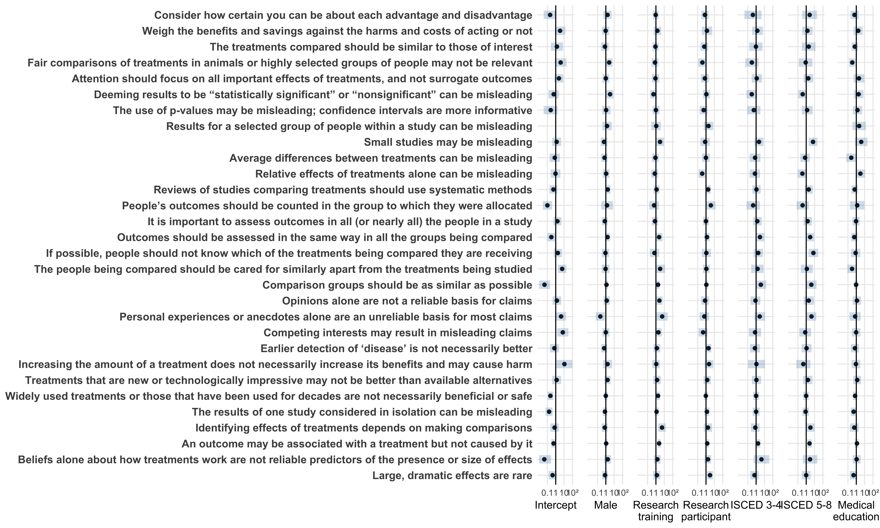

#### Attitudes and intended behaviors

The following table presents the results of analyses performed to explore the associations between demographic covariates and Norwegians’ attitudes and intended behaviors. Results are presented as odds ratios. Odds ratios greater than unity indicate that a covariate is associated with having a particular attitude or intending to engage in a particular behavior.

As before, some odds ratios are clearly misestimated. For example, the odds ratio for ISCED Levels 3-4 for the attitude “Easy to assess if claims are based on research that compares treatments?” is estimated to be 2.3e+07 (8900000 to 6e+07). As before, this problem may be explained by collinearity between the dependent variable (understanding the concept) and education (ISCED level).

|  |  |  |  |  |  |  |  |  |  |
| --- | --- | --- | --- | --- | --- | --- | --- | --- | --- |
|  | Sample |  | Intercept | Male | Research training | Research participant | ISCED Levels 3-4 | ISCED Levels 5-8 | Medical education |
| Willing to take part in research? | 541 / 771 | (70%) | 1.6 (0.83 to 3.1) | 1.1 (0.72 to 1.7) | 1.1 (0.71 to 1.8) | 1.4 (0.8 to 2.3) | 0.96 (0.47 to 1.9) | 1.3 (0.67 to 2.6) | 1.1 (0.64 to 1.8) |
| Willing to challenge claims? | 140 / 172 | (81%) | 4.7 (0.42 to 52) | 1.9 (0.63 to 5.7) | 1.7 (0.49 to 5.9) | 1 (0.31 to 3.3) | 0.16 (0.021 to 1.2) | 1 (0.11 to 9.3) | 1.8 (0.44 to 7.5) |
| Likely to research the basis of claims? | 130 / 172 | (76%) | 1.2 (0.2 to 6.9) | 3 (1.1 to 8.2) | 1.3 (0.45 to 4) | 1.5 (0.42 to 5) | 0.53 (0.1 to 2.8) | 1.8 (0.33 to 10) | 2.8 (0.65 to 12) |
| Easy to assess if claims are based on research that compares treatments? | 42 / 172 | (24%) | 5.4e-09 (3.3e-09 to 8.8e-09) | 1.3 (0.52 to 3.1) | 2.1 (0.83 to 5.4) | 1.5 (0.49 to 4.8) | 2.3e+07 (8900000 to 6e+07) | 4.5e+07 (2e+07 to 9.9e+07) | 0.96 (0.33 to 2.8) |
| Easy to find research based on studies that compare treatments? | 36 / 172 | (21%) | 0.15 (0.031 to 0.75) | 0.9 (0.36 to 2.3) | 1.6 (0.47 to 5.2) | 5.7 (1.9 to 17) | 0.59 (0.095 to 3.7) | 0.7 (0.11 to 4.7) | 1 (0.24 to 4.1) |
| Easy to assess the credibility of results of studies that compare treatments? | 32 / 172 | (19%) | 0.18 (0.032 to 0.97) | 3.8 (1 to 14) | 4.4 (1.4 to 14) | 1.2 (0.25 to 5.7) | 0.057 (0.0049 to 0.68) | 0.32 (0.041 to 2.5) | 0.94 (0.19 to 4.7) |
| Easy to assess the relevance of study results? | 35 / 172 | (20%) | 0.26 (0.044 to 1.6) | 1.8 (0.58 to 5.9) | 1.7 (0.58 to 4.8) | 1.4 (0.48 to 4.2) | 0.36 (0.032 to 4) | 0.44 (0.048 to 4) | 2.4 (0.71 to 8.1) |

The results in the table above are presented graphically below. Note that confidence intervals extending outside axis ranges are clipped.

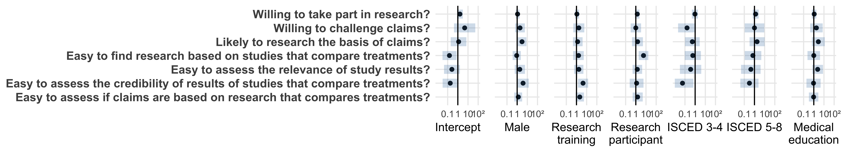

#### Mean score, passing, and mastery

The following table presents the results of analyses performed to explore the associations between demographic covariates and Norwegians’ mean scores and achievement of passing and mastery scores. Results for mean score are presented as percentages. Results for passing and mastery are presented as odds ratios. Odds ratios greater than unity indicate that a covariate is associated with achieving passing or mastery scores.

Note that the result for passing is unreliable because all but one of the Norwegian respondents achieved a passing score. The one Norwegian who did not achieve a passing score was not educated past primary school level (ISCED levels 0-2), did not have education in research or medicine, and had been a research participant.

|  |  |  |  |  |  |  |
| --- | --- | --- | --- | --- | --- | --- |
|  | Intercept | Male | Research participant | ISCED Levels 3-4 | ISCED Levels 5-8 | Medical education |
| Mean score | 75.0% (68.0% to 82.0%) | -2.3% (-6.6% to 2.1%) | 0.6% (-5.5% to 6.7%) | 5.0% (-2.9% to 13.0%) | 11.0% (4.0% to 19.0%) | -0.4% (-5.2% to 4.4%) |
| Passing | 5.8e+33 (6.9e+32 to 4.9e+34) | 6.7e-23 (6.4e-24 to 7.1e-22) | 3.8e-23 (5.9e-24 to 2.4e-22) | 2e+22 (2.2e+21 to 1.8e+23) | 2e+22 (3e+21 to 1.3e+23) | 0.28 (0.063 to 1.2) |
| Mastery | 0.53 (0.17 to 1.7) | 0.81 (0.36 to 1.8) | 1.7 (0.54 to 5.1) | 0.89 (0.26 to 3.1) | 3.5 (1 to 12) | 1.3 (0.42 to 4.1) |